Artificial Neural Networks

The aim of The project was to generate an Artificial Neural Network, which would then be used to predict the outputs to sample inputs.
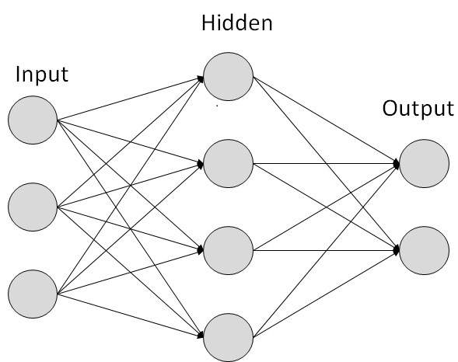
At the start of the project the plan was to find pressure coefficient on a buildings outer surface, to utilise natural wind flows to cool certain points in the buildings. To do this a list of inputs such as dimensions and other factors and their corresponding output pressure coefficients were given. So then the plan was to use these inputs and outputs to generate an Artificial Neural network. The example given was an excel version that had numerous calculations to do this, then task was to replicating the process from the excel file on a software called Easy NN. It was unknow software and found it hard to understand how to use it and could not find much online support on how to use the software making it not that reliable for the task. So a software much familiar was used matlab and tried the task again. After doing some research online multiple ways of creating an Artificial Neural Network were found, the easiest of which was the nntool function a graphical interface that allowed to generate a network by giving it the inputs and the outputs. A network that had a single input and output was then trained and used to predict output for a sample input which was successful. This was then further tested for a network that had multiple inputs and a single output. Another method used was coding which was successful in recreating that the graphical interface did after numerous trial and error. The upside of using this method was that it automatically updated the Artificial Neural Network based on the availability of new training data. And the last method was using the nnstat function that created a network like the other graphical interface but also a code to go alongside it which was similar to the coded method making it reliable. As a final task all three methods where then used to test the outputs given for sample inputs to see if the results where similar.
There was a lot of new and interesting knowledge gained for this placement especially on Artificial Neural Networks, their function and the many possibilities it has. This placement was very beneficial as it could help with future studies and helped gain an understanding of have a placement work. And also hopes that the code created by the end of the placement can contributing to other people working on similar tasks.

